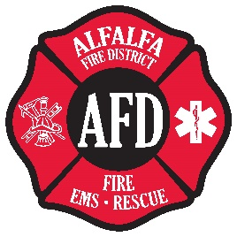
ADDRESS SIGN APPLICATION
Alfalfa Fire & Rescue are offering address signs for a cost of $30.00. These signs comply with the Deschutes County Ordinance requiring adequate signage. Signs will be manufactured on 6” X 13” reflective stock and mounted on posts. Price includes the sign, post, line locations and installation. If a common access serves several homes, it may be necessary to order and place additional signs to clarify the location of your home.
Please fill out this application form below. You can provide a drawing of any specific sign location details you wish to provide on the back of this form. Return the form, along with $30.00 for each sign ordered to:
ALFALFA FIRE DISTRICT 25889 ALFALFA MARKET RD BEND, OR 97701
Please draw a sketch of your lot on the reverse side of this form showing the following: (1) Location of the residence on the lot (2) Driveway location and connection to the county road or city street (3) Approximate distance to nearest intersection (4) Special hazards on the property. If you live on a corner lot, please identify both streets bordering your property. We will manufacture the sign(s) and install them to ensure consistent locations and identification of your property.
Property Owner Name: ______________________________________________________________________
Property Address: ______________________________________________________________________________
Nearest Crossing Street:______________________________________________________________________
Phone:________________________________________
Email:________________________________________
Number of Signs Needed:
Please allow 4-6 weeks for processing, manufacture & installation of your sign(s)

