ALFALFA FIRE DISTRICT

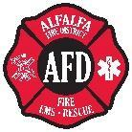

Special Meeting

Alfalfa Fire Station

25889 Alfalfa Market Rd., Alfalfa, OR
July 20th , 2022 - 6:00 p.m.

PLEASE MUTE OR TURN OFF CELL PHONE
AGENDA

1. Call to order / Pledge of Allegiance / Roll Call

2. Additions to Agenda / Visitor Input / Public Comment

- Review and sign resolution, 2022-07 (22/23 budget )

The next board Business meeting will be Wednesday, August 10th 2022 @ 6 PM.

Adjourn

